RESEARCH KNOWLEDGE TRANSITIONS & COMPOUND HAZARDS

Generating Ideas for Adapting Social Science to Your Workspace
VIRTUAL WORKSHOP

June 6-7, 2023


www.redlaboratory.org/r20

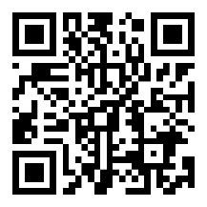

Hosted by

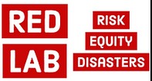

Partnering with
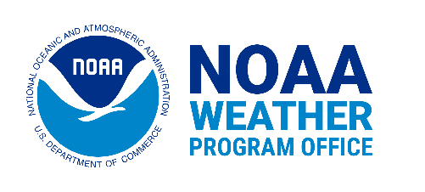

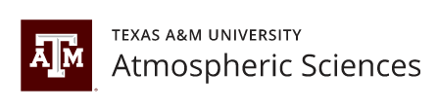

FOREWORD

Welcome to the first virtual workshop, “Research to Operations (R2O) & Compound Hazards: Facilitating Social Sciences Applications and Perspectives for the Weather Community.” We are thrilled to have you here!

The concept of transitioning new knowledge into different workspaces has evolved over the years. Various names include co-production of knowledge, applied knowledge, actionable or usable knowledge, policy relevant knowledge, or within federal agencies in the US, Research to Operations (R2O). Originally, R2O was defined as moving scientific research findings into applied and operational spaces like the National Weather Service. More recently, the concept has expanded to include O2R2O, R2X, and Research Transitions, more generally. In each instance, the common goal is to find ways for new knowledge to be transformed into useful and usable applications for others. Ideally, it is conceptualized as a two-way process that generates not only new knowledge for operational and practitioner communities, but new knowledge is also informed by the needs, challenges, and ideas from the operational and practitioner communities. And social science knowledge is new to this transition space in for NOAA. Regardless, we believe there are still gaps in how we understand all the ways that knowledge can make its way into workspaces and become useful. This is where you come in!

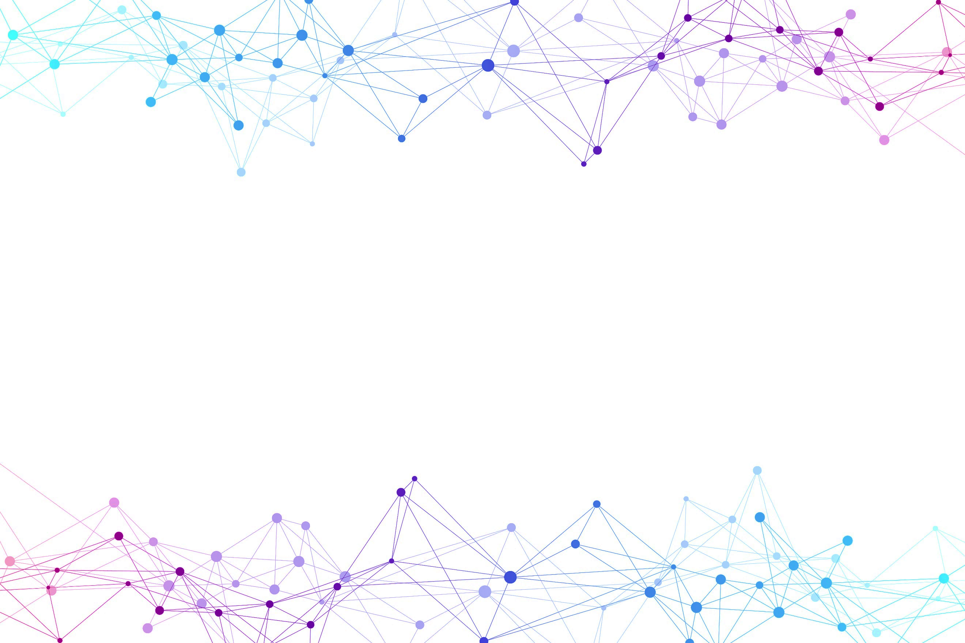
During the workshop, we will learn how different groups in the Weather Enterprise (e.g., broadcast meteorologists, emergency managers, NWS forecasters) think about transferring new social science research into their respective workplaces. Researchers from the Risk and Equity in Disasters (RED) Lab will discuss how preliminary findings from interviews and surveys about tornadoes and flash floods (TORFFS) in landfilling tropical cyclones can be helpful to different agencies and organizations in their operations.

WORKSHOP AGENDA
DAY 1 | Tuesday, June 6, 2023

Welcome Message
Participants Introductions
What is Social Science?
We propose that you: Think and reflect on how theoretical concepts and methodological approaches of social sciences can be useful to your workspace.
Useful concept: Human systems and interactions with the weather and the built environment.
You’ll learn: A compiled definition of social science and how it (historically has) and still can contribute to the weather community.

What Does Bringing New Knowledge Into Your Workspace Look Like for You?
We propose that you: Discuss your own experiences adopting new knowledge about topics relevant to your work and how you’ve incorporated them into your workspace.
Useful concept: Actionable knowledge/co-produced knowledge
You’ll learn: What are a few of the more common frameworks that describe how knowledge is created and how it can be put into practice. Specifically, we’ll look at how other participants understand transitioning knowledge into practice, including NOAA’s R2O framework.

TORFF: Preliminary Research Results
We propose that you: Discuss the preliminary results from the research project “Improving Knowledge about NWS Forecaster Core Partner Needs for Reducing Vulnerability to Compound Threats in Landfalling Tropical Cyclones Amid Covid-19” led by Dr. Jen Henderson, Erik Nielsen, & Rodolfo Hernandez.
Useful Concept: Compound hazards and cascading risks/vulnerabilities.
You’ll learn: Why compound risks and hazards are essential to account for in the weather warning system. Specifically, how compound hazards that co-occur during landfalling tropical cyclones impact risk communication and job stresses of broadcast meteorologists and emergency managers.

Transitions to Your Space
We propose that you: Creatively propose scenarios of how you might transition compound hazards knowledge into your space.
Questions that we will ask you: What have you done in the past to transition new knowledge into your space? What formats and templates for knowledge are the most useful to you and your colleagues?
Useful Concept: transition / transfer definitions and examples
You’ll learn: How others in the Weather Enterprise encounter new knowledge and make it useful in their own work

Wrap-Up & Insights

WORKSHOP AGENDA
DAY 2 | Wednesday, June 7, 2023
Welcome Message
A-ha Moments from Day 1
Transitioning Social Science (R2X): NOAA WPO SBES Talk
We propose that you: Think about the research to transitions framework proposed by the Social Science Team at NOAA’s Weather Program Office
Useful concept: Research knowledge transfer
You’ll learn: NOAA’s approach to R2X framework, including the transition of social science research and data into an operational environment.

R2X Examples From the Field
We propose: Two short presentations that offer examples of how people have either moved research into operations or are looking to find a use for their research.
Useful Concept: Transition strategies to apply to your decision space.
You’ll learn: One practical example of how the concept of TORFF has been translated into operations within the NWS. It illustrates an education initiative initiated from a social science paper that was transformed into operations through training modules and day-long training. The other is an example database that is ready for use. However, it is unclear which format, temporal and spatial scales, and decisions it would best support.

Discussion & Suggestions for R2X
We propose that you: Creatively propose scenarios of how you might transition compound hazards knowledge into your space.
Questions that we will ask you: Which example is most pertinent to your workspace? How might you adapt or build on these examples for yourself or others?
Useful Concept: R2X processes and challenges
You’ll learn: A process for how one social science paper was transitioned into NWS operations and an example of research in need of R2X ideas.

Moving Forward & Sharing Final Ideas
Wrap-Up & Next Steps



LOGISTICS & RECOMMENDATIONS
GET READY
- This workshop it’s not open to the general public. The organizing team invited partners and collaborators in the Weather Community.
- The Risk & Equity in Disasters (RED) Lab has prepared a website with great resources. Check them here: https://www.redlaboratory.org/r20 We will keep this record so you can always come back for materials that you might want to use again in the future.
- We will use Google Meets to facilitate the workshop. We recommend using Google Chrome to open the virtual call links (Day 1) (Day 2). Don’t forget to test your microphone and video beforehand.
- Additionally, we will share Google Docs and Jamboards to collect participants’ opinions, which will serve to systematize the reflections throughout the sessions, for future analysis, and dissemination of results.
- All the information collected will be anonymized and only transcripts will be used. We will de-identify personal and professional information. Mindful of the ethics involved, we will ask a verbal permission to audio record the workshop to use the data collected for future workshop designs and follow-up publications.

DURING THE WORKSHOP
- When you log in (Day 1) (Day 2), please write down your name and affiliation on your profile. We also recommend including your pronouns.
- During presentations, please keep the microphone off. You are welcome to share comments and links in the chat.
- For breakout rooms, we have prearranged groups by interest and type of affiliation. Although we encourage sharing new interactions, we acknowledge we have limited time and want to use the time efficiently.
- We’ll have short breaks between sessions. Try to come back on time so we can keep up with the agenda. If you experience any technical issues or you have to leave a session unexpectedly, please keep us updated by emailing Megan Porter at megan.s.porter@ttu.edu
- If you have suggestions for other resources, please feel free to share them via the chat or email.

AFTER THE WORKSHOP
- Let us know if you have any ideas or further contributions, you would like to discuss. Our email is: geosciences.redlab@ttu.edu
- Also, if you want to open a discussion space with your team, we will be happy to explore future interactions with groups of people interested in Research to Transitions and the social sciences.

DAY 1

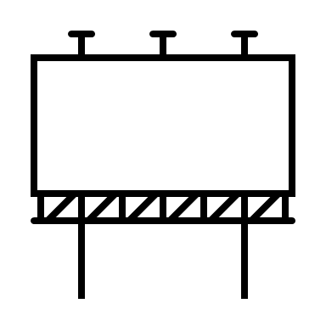KEY CONCEPTS: SOCIAL SCIENCES
Social sciences are a group of disciplines that study human behavior and the interactions with ecosystems and the built environment.

TURNING POINT
“During the past several decades (…) other fields and disciplines have begun to see themselves as part of the social sciences, slowly giving rise to recognizing other disciplines as part of the social sciences (…) The lines of demarcation between fields of study and disciplines, then, have become blurred, but among the several linchpins that seem to hold them together as the social sciences, are their research methods”. Given, L. M. (Ed.) (2008). The SAGE Encyclopedia of Qualitative Research Methods. (Vols. 1-0). SAGE Publications, Inc. https://doi.org/10.4135/9781412963909
QUALITATIVE APPROACHES
“Although most people tend to associate computer technology and the internet with more quantitative number-crunching activities, in fact, qualitative research in the social sciences has reached out to embrace technology as well. Self-administered interviews, laptop computers, or e-interviews conducted entirely in real time and over the internet are fast becoming more common. Explorations of blogs permit investigators to conduct phenomenological explorations of the social worlds of people involved in a wide assortment of areas, fields, and occupations. Even participant observation can be undertaken in a high-tech fashion through the use of digital cameras either attached to a computer or connected by way of wireless transmissions to monitor a particular setting, individual, or group. As qualitative researchers in the various social sciences continue to move forward through the current millennium, it seems clear that they not only will continue to expand their orientations and strategies for data collection, but also will remain tied to the overall qualitative paradigm”. (Given, L.M. (Ed.) (2008).

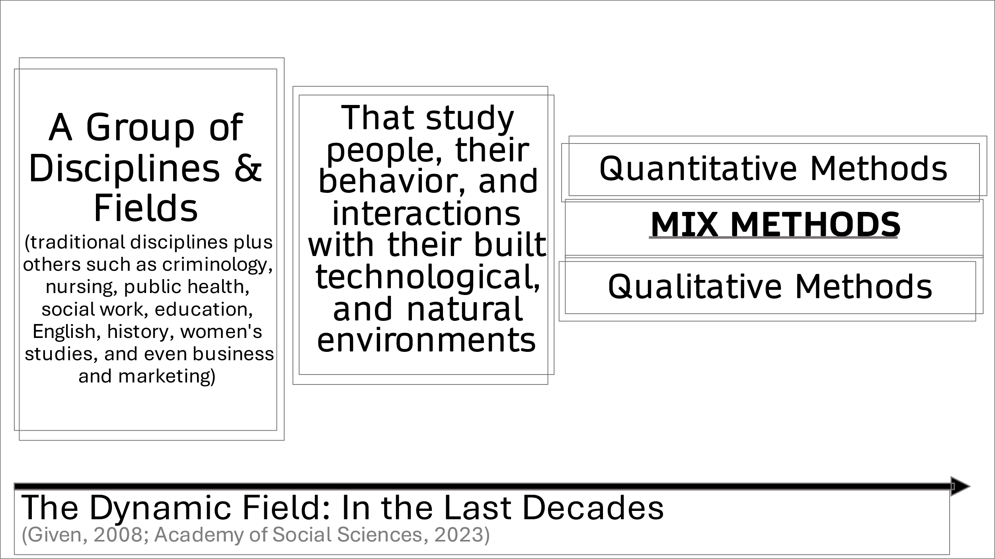
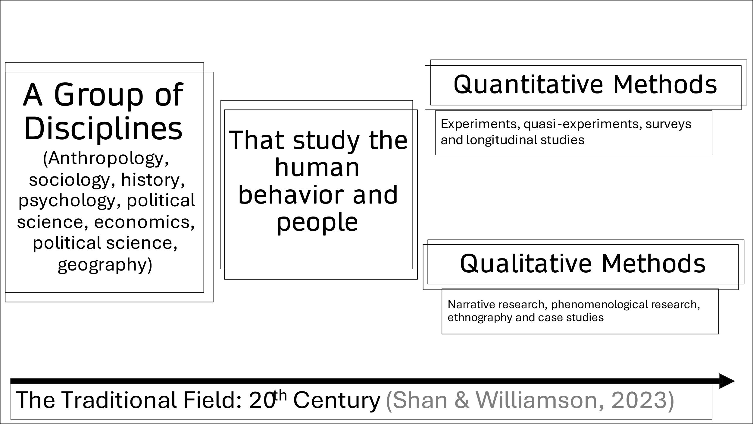
KEY SLIDES

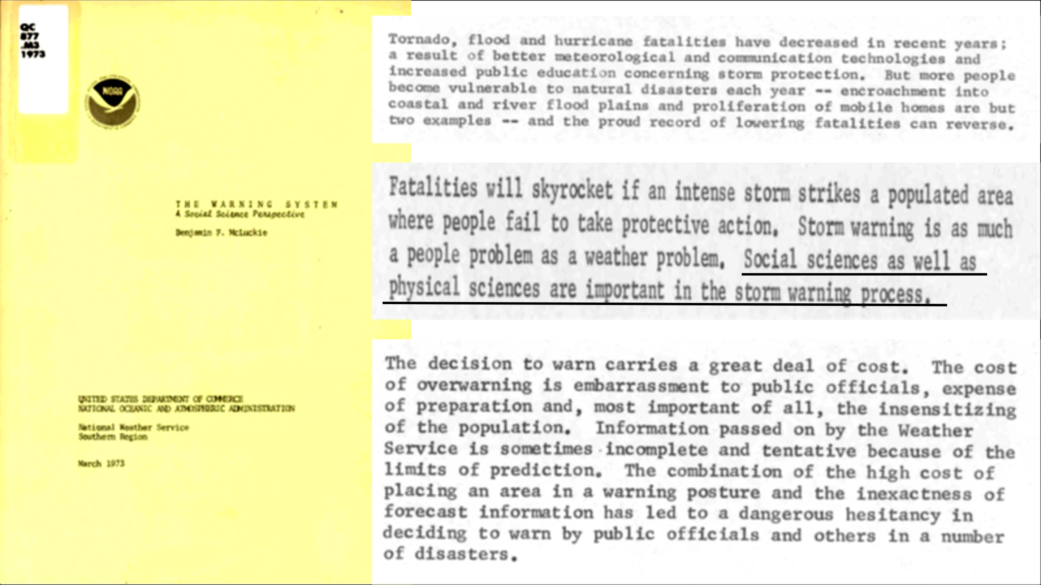
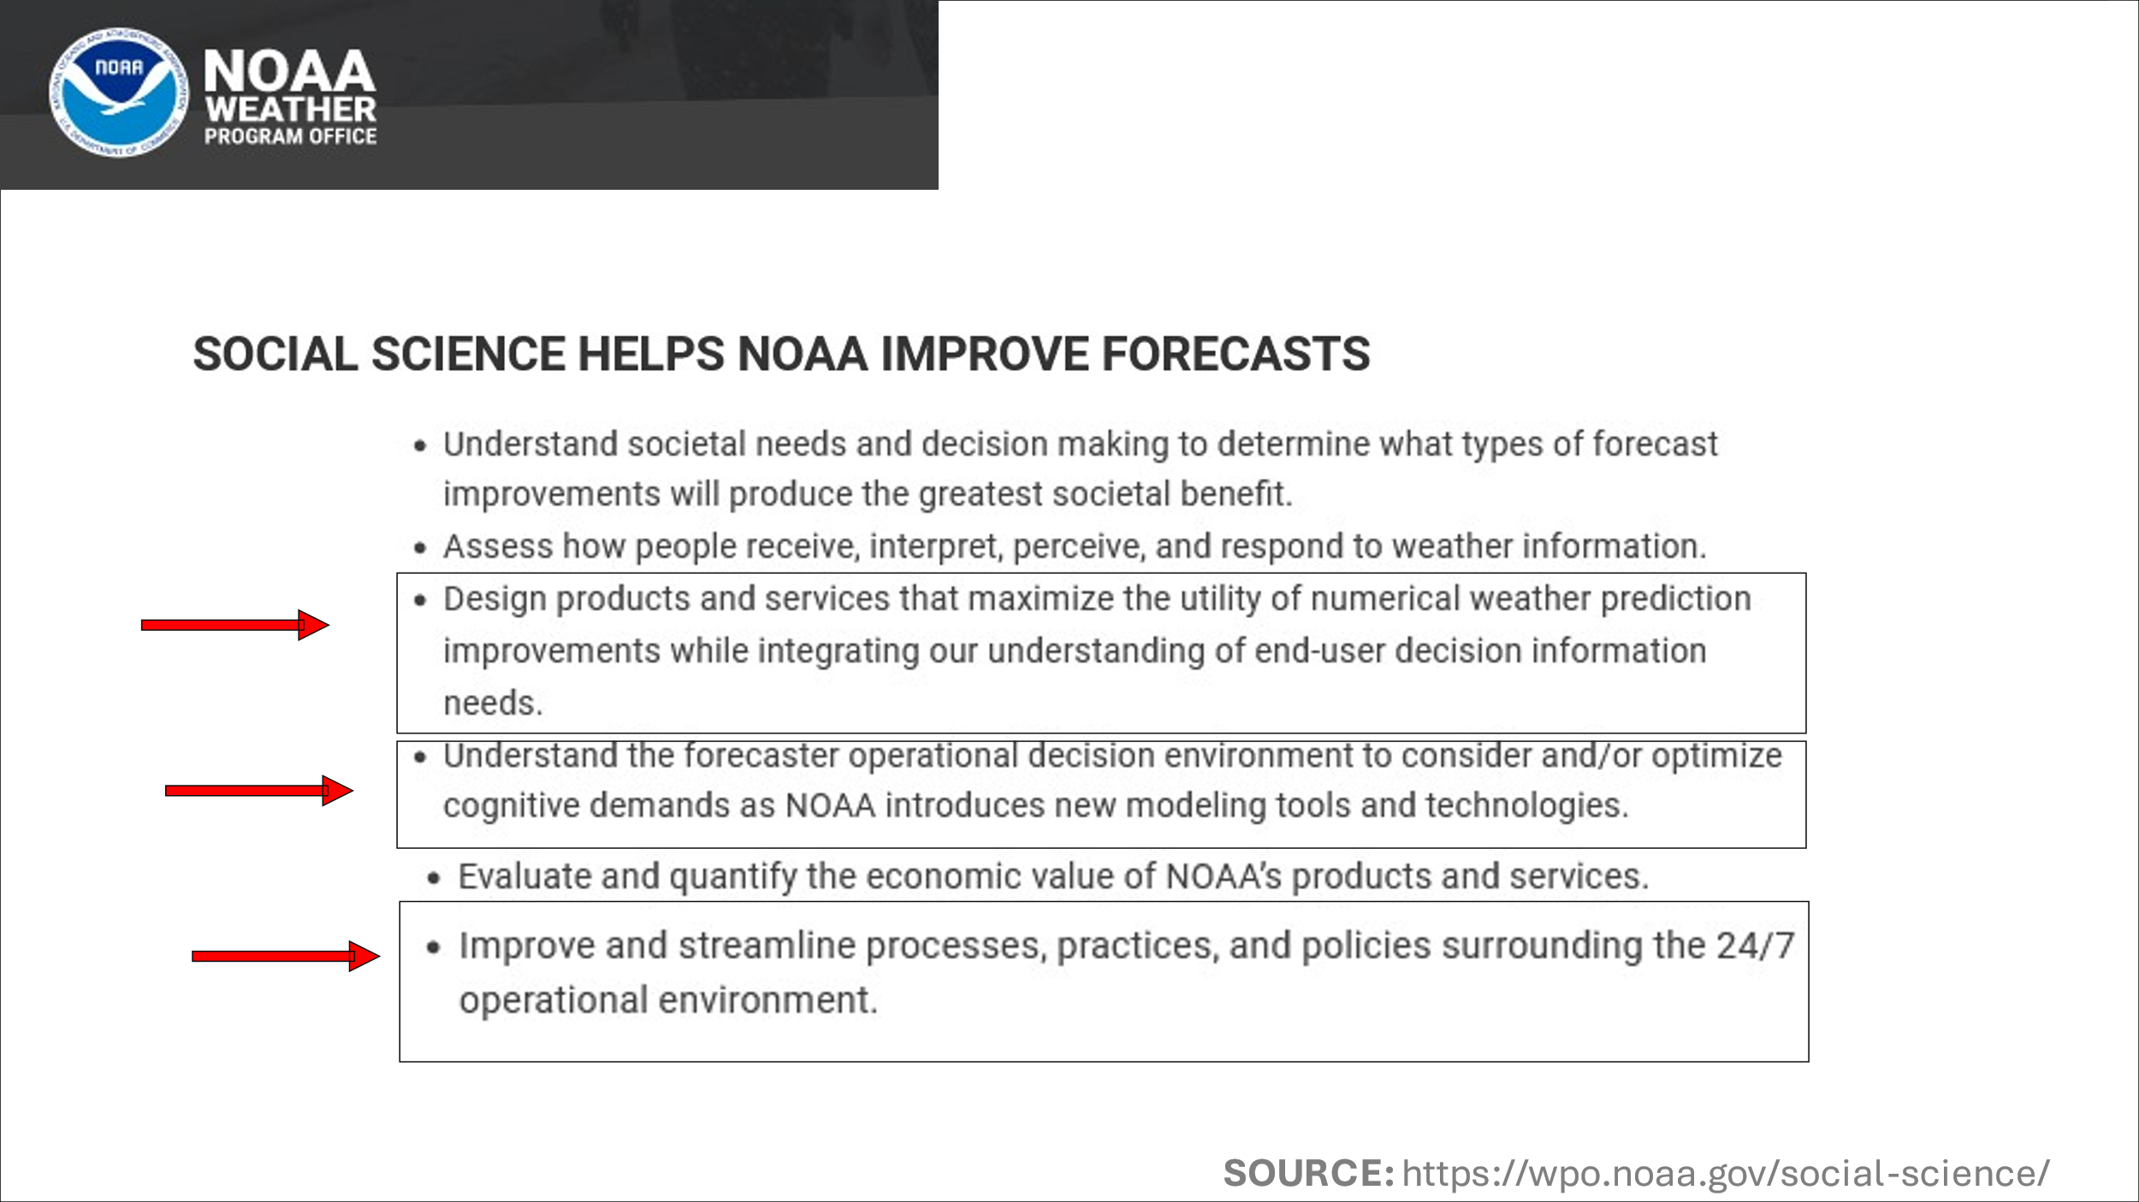

NOTES:
KEY CONCEPT: CO-PRODUCTION OF KNOWLEDGE
DEFINITION: Co-production is an approach to knowledge creation with the outcome of creating usable and useful applied information tailored to specific users (e.g. stakeholders, partners, decision-makers). It is based on three basic tenants. Co-production....
•Is an iterative, flexible process of creating knowledge with stakeholders
•Begins with understanding stakeholders’ decision contexts, challenges, resources, and goals
•Designs usable knowledge that meets stakeholders’ specific needs
Co-production can be a formalized process, like one created by grant-related outcomes, or it can be an informal process of continually assessing decision-maker needs over time.
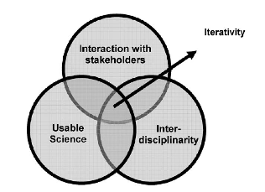
Assumptions about Co-production:
“The underlying assumption [of co-production] is that, because many factors affect if, when, & how knowledge creation and application interact, no single research model” can fulfill [goals in all contexts] (Lemos & Morehouse, 2004, p. 58).
“There is a time dimension to [co-production] in that it is often necessary to create new knowledge in order to address stakeholder needs: years may need to pass before stakeholders perceive this new knowledge as usable [and useful] for decision making” (ibid, p. 58).
Lemos, M. C., & Morehouse, B. J. (2005). The co-production of science and policy in integrated climate assessments. Global environmental change, 15(1), 57-68.

KEY SLIDES
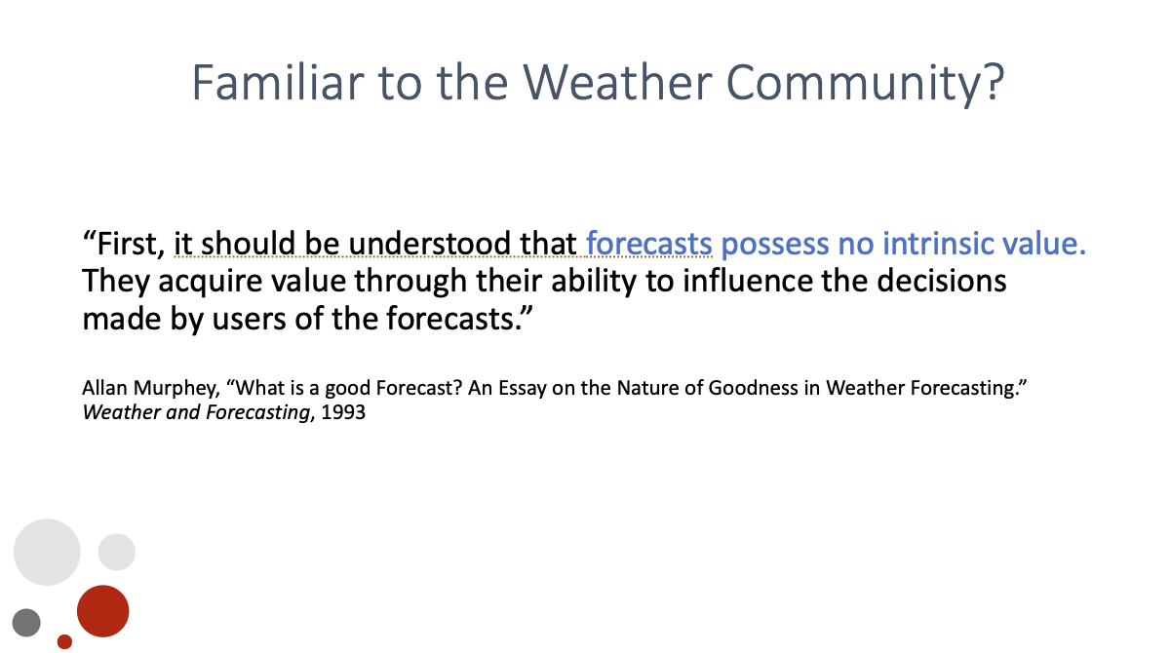

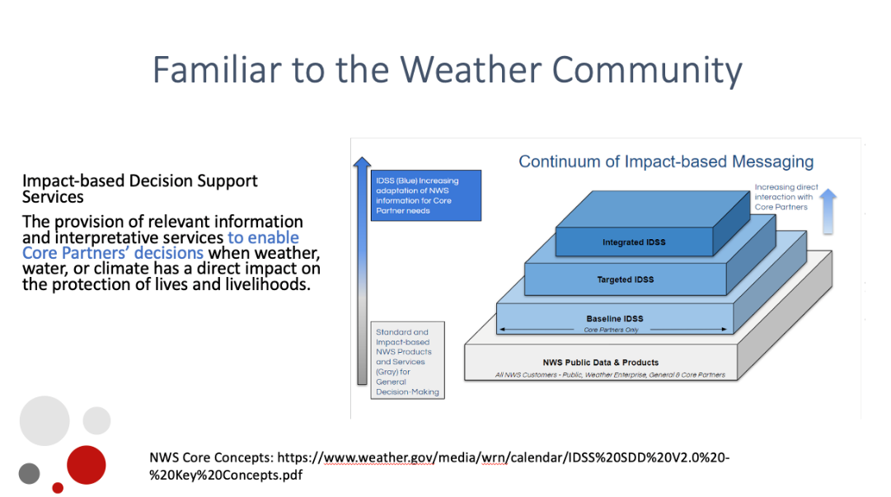
NOTES:

Breakout Group Prompt: When you hear or learn something new and potentially useful to your work in the Weather Community, how do you bring it into your workspace and apply it?

KEY CONCEPTS: TORRFS & CASCADING DISASTERS
When tornadoes co-occur with flash flooding, what we call TORFFs, warnings for a particular location can contain contradictory advice that can complicate people’s understanding of the threat that is most dangerous to them: warnings for tornadoes suggest people get to the lowest part of a structure and flash flooding suggest people get to the highest part of their home.
RESEARCH PROJECT: “Improving Knowledge about NWS Forecaster Core Partner Needs for Reducing Vulnerability to Compound Threats in Landfalling Tropical Cyclones Amid Covid-19”
FUNDED BY: The 2021 Weather Program Office Research Programs, NOAA
GOAL: To develop knowledge about compound wind and water hazards during landfalling tropical cyclones (e.g. Hurricane Ida) amid Covid-19:
- how NWS partners in emergency management and broadcast meteorology attend to, assess, and communicate compound hazards in Hurricane Ida given Covid-19 surges
- how this understanding shapes and is shaped by partners’ conceptualizations and indicators of the public’s changing vulnerability
- what pathways for research-to-operations (R2O) can be developed for products, processes, and practices that can help build forecaster and core partner knowledge and situational awareness of compound hazards
KEY SLIDES
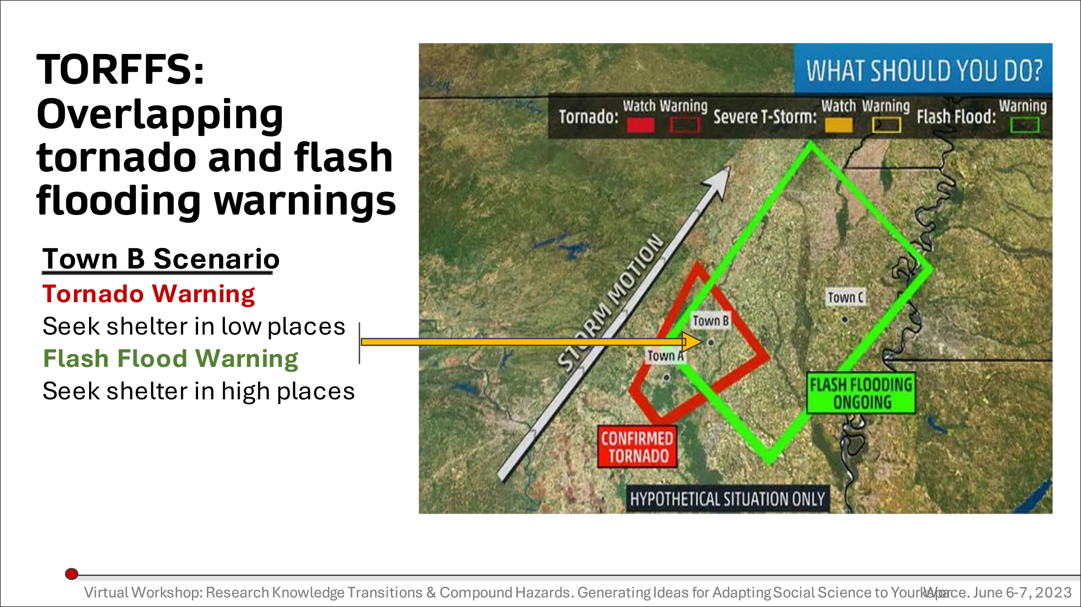

NOTES:

Breakout Group Question: How might you bring knowledge about TORFFs generally or from our research specifically into your workspace?

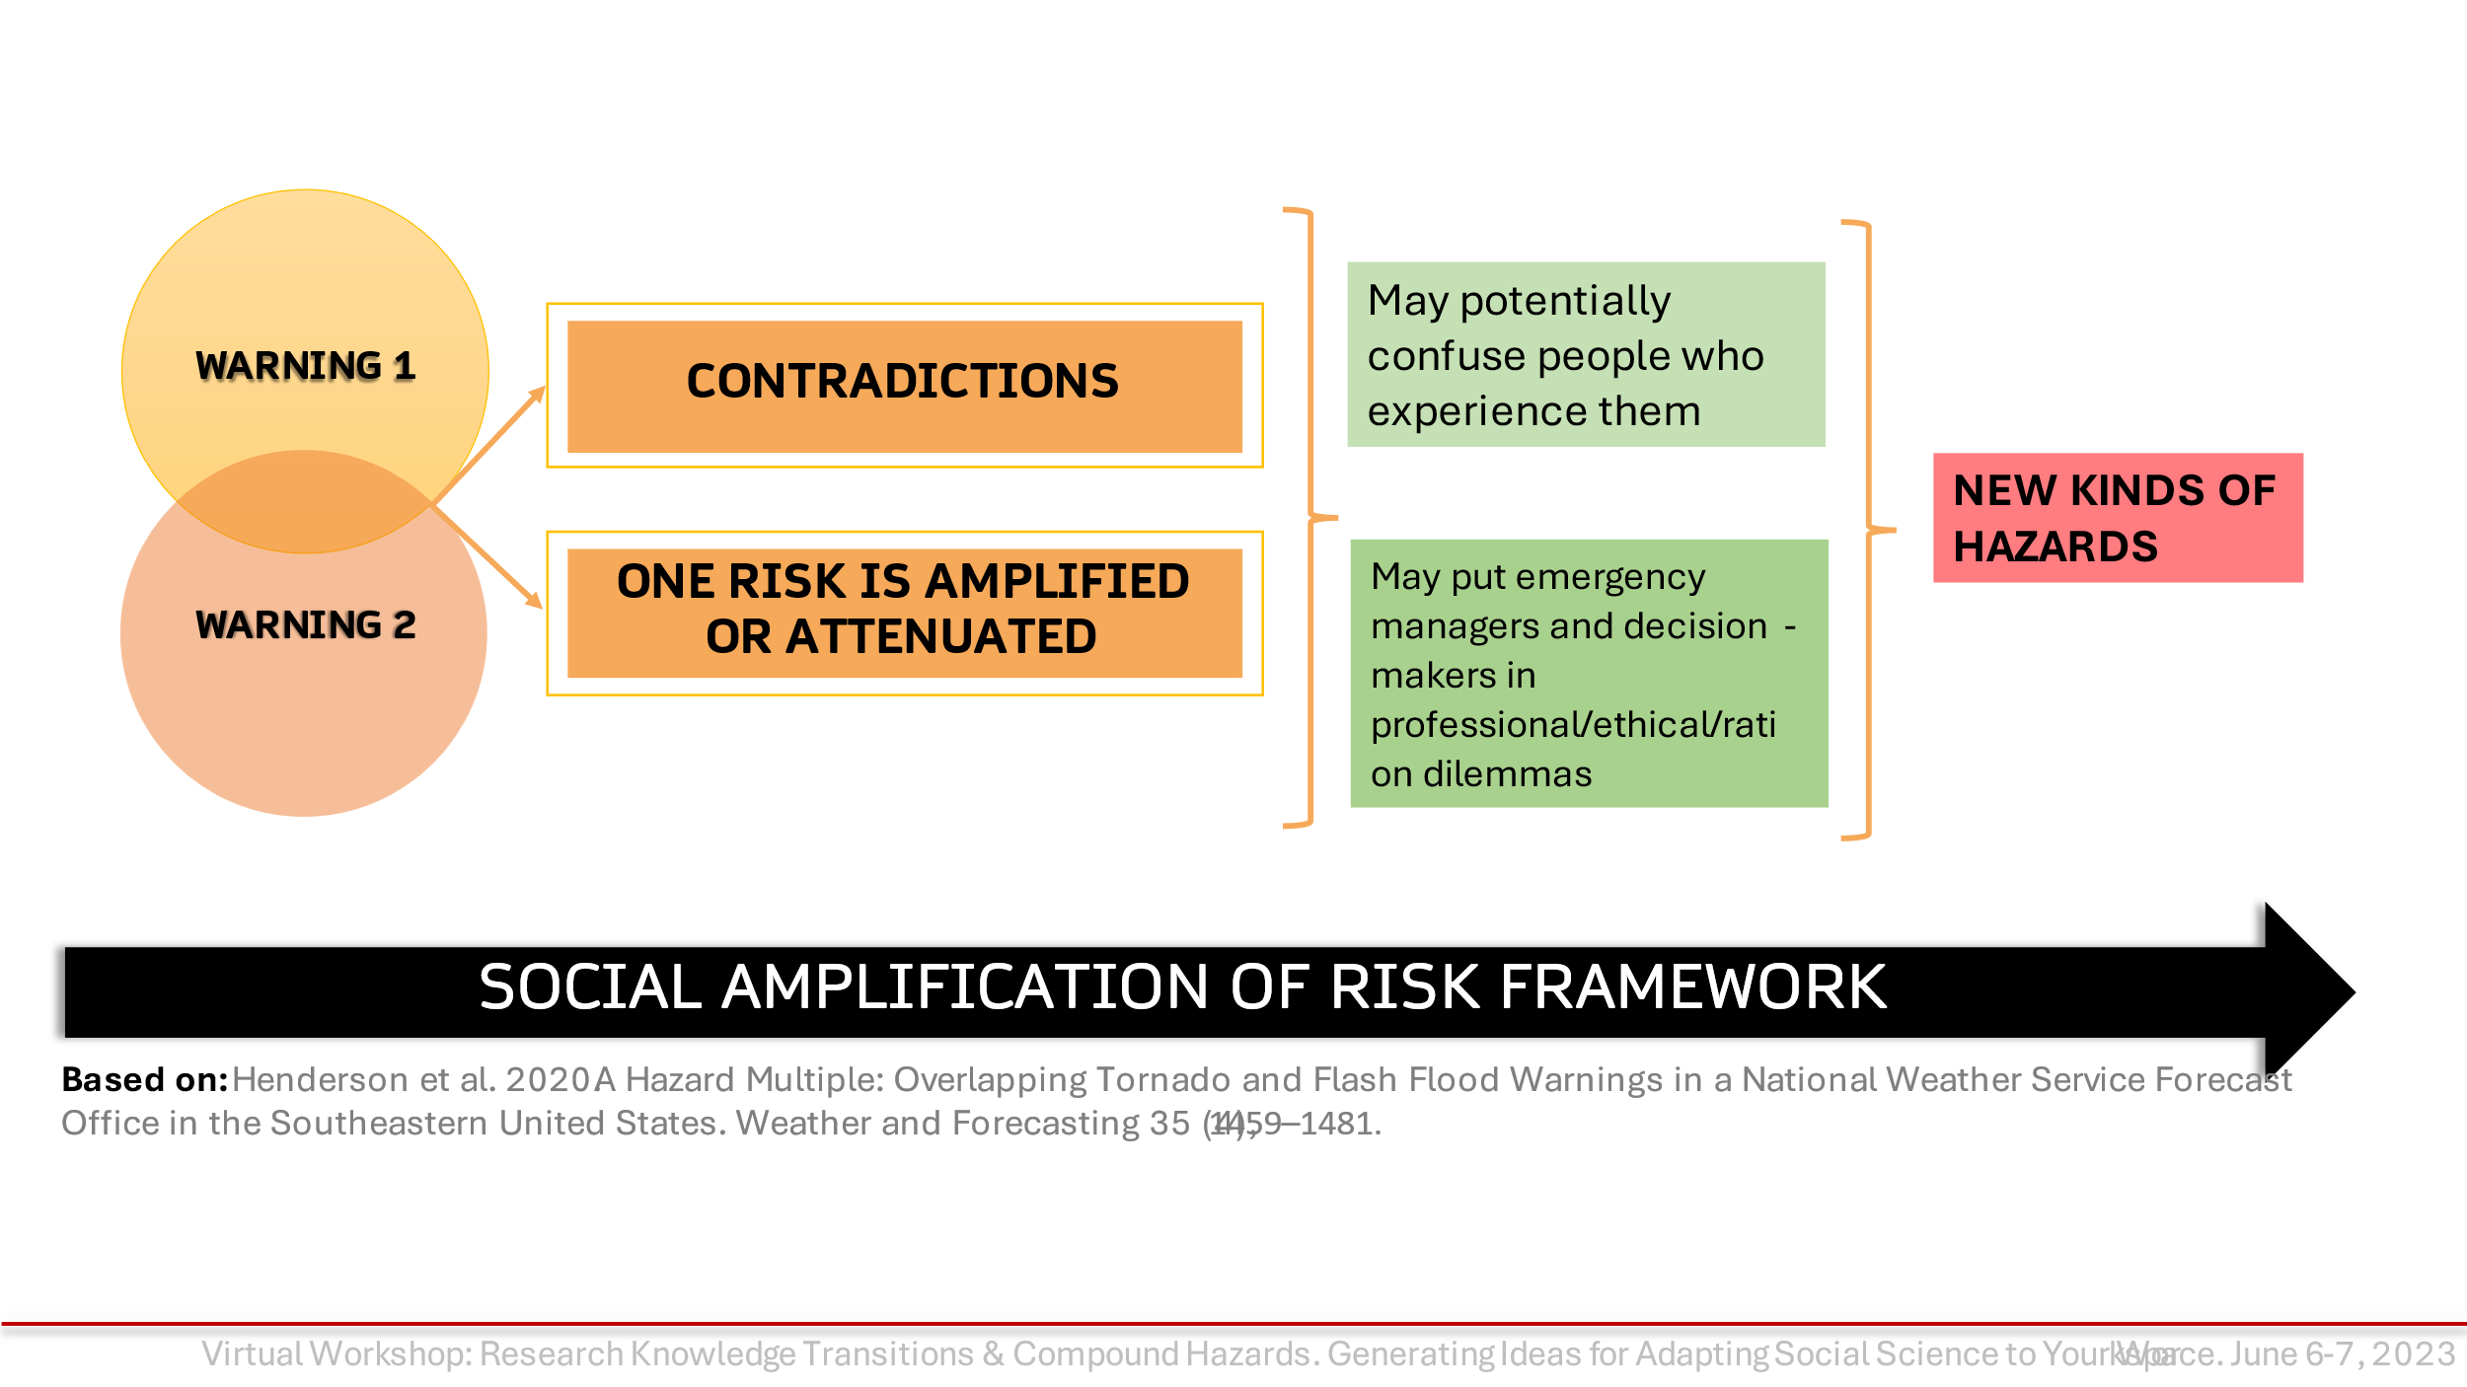

NOTES:

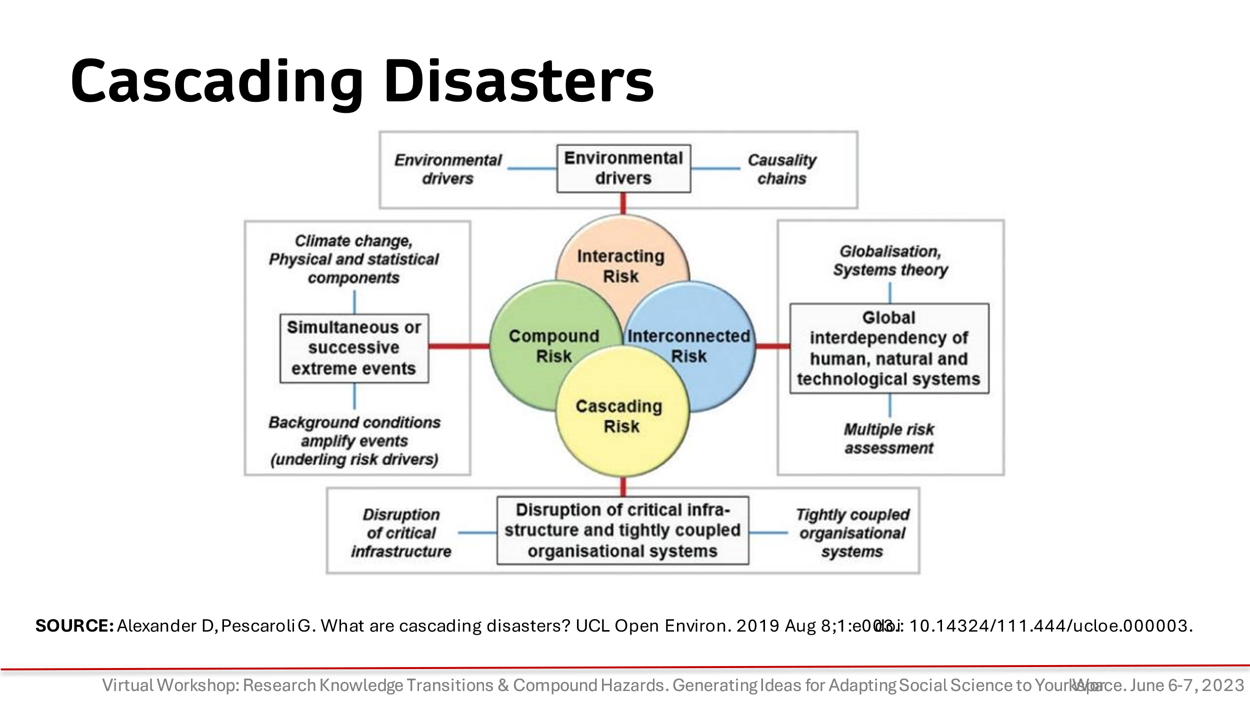

:

TOPICS FROM OUR RESEARCH:
Findings from NWS Service Assessment of Hurricane Ida (2021) & Our Data about TORFF Emergency

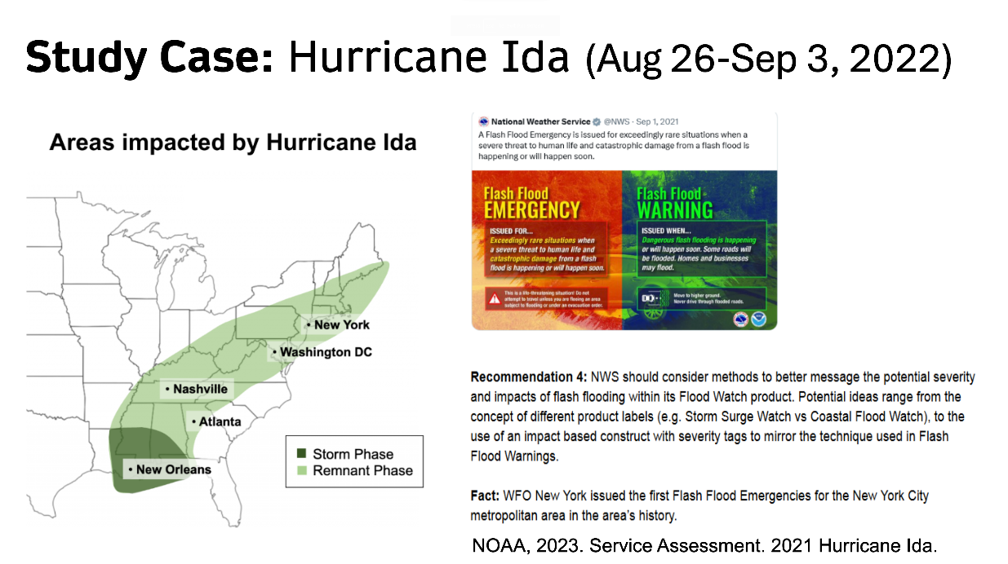
NOTES:

Other issues raised in our data: Stress / Fatigue with Compound Hazards; Tools to Simplify Jobs
Stress of the Job’s Multiple Roles
“When a mom is saying, 'I'm here with my three kids, and nobody's helping us, and we're drowning', you have to keep them through your head, and you have to try to give them the best information that you can. But if you know some of those situations, it shouldn't be us, right? But unfortunately, it's what it's become. We become the therapist, the scientists, geologists, we got to talk about earthquakes. And like, they all if it's about an eclipse, they cover me, I'm like, 'How did I become all these things?'” -- Bilingual Broadcast Meteorologist

Spanish Glossary & Cohesive Messaging
“For me... I've kind of mentioned to one other colleague about ... having kind of what the AMS is working on now: A glossary in Spanish to help communicate certain hazards because, of course, while there are some general terms that do go [across] different countries for certain events, there's also different ones that kind of, you know, become more of a localized kind of word for things. I feel it would make it easier to describe, especially for me. You know, while I do write and read [Spanish] at a classroom level, in Spanish it takes me some time to be able to communicate these things, especially on social media, things of that sort. So having that kind of tool to be able to just look quickly, instead of having to think and try to find [words]. Like, 'Hey, I have this quick glossary, boom, boom', slide it over. Kind of like, that's exactly the term I wanted to use and ... boom, there we go. Kind of give me an easier tool to help with faster communication on that on my end. But then again, I know there are native speakers of Spanish that do it a lot quicker, but I feel like that tool will just be helpful for everyone, especially in a more cohesive message for community.” --Bilingual Broadcast Meteorologist

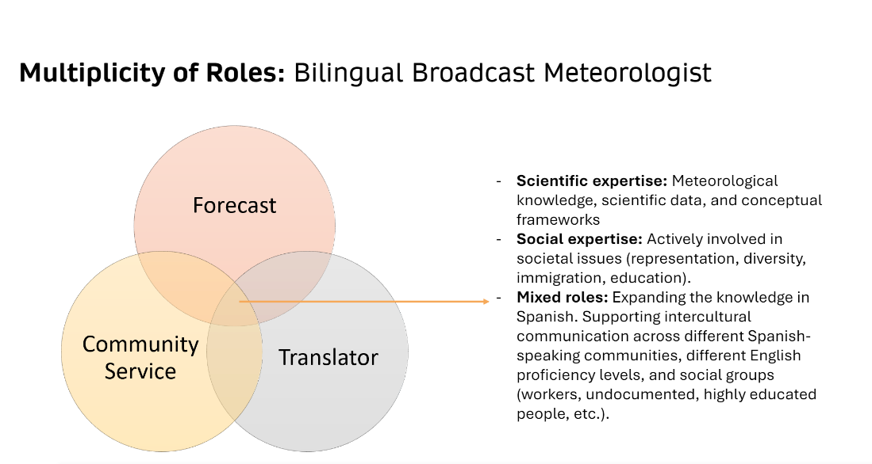
NOTES:

Stress of Covid-19 on Staff
“COVID changed everything. And that is, I have two people in my office right now today. I've got everybody working from home as much as they can, when we're doing this stuff. Our EOC this year, during Ida, we've had to, you know, great challenges with trying to keep people healthy. My office has worked throughout all of COVID for two years, while most of my building here at City Hall has worked remotely.” --Emergency Manager
Stress of Constant Threats on Population & Communication
“We know that extreme weather events continue to impact the country, we know that climate change is a real issue that we're continuing to experience. And I think it's now become part of the repertoire. And like, part of […] the collective consciousness of residents across every jurisdiction is not like ours. You know, sometimes what happens is when an emergency like this [Ida] happens, people will say, ‘Oh, we experienced this, but we were fine. We bounced back, we're resilient, we figured it out’. But I think that so many people were affected by this and weren't expected to be affected by this, because they're like, I don't understand. I don't live near water. I think that is something that has really resonated with people today is that, you know, obviously some people say coastal storms or hurricanes, I don't live in a zone, I'm fine. But flash flooding affects everybody.”
“Our greatest […]concern always when you wear people down with these things. When a residency or a group in your city get beat down constantly, over the course of three and a half years by 17 declarations--and hopefully, some of those things have been a little seamless and maybe not affected everyone the same way. But we have had some big events, you know, both infrastructure-related and natural disaster-related that have definitely been trying for our residents. So we do have to continue to try and engage with our public and make sure that, I hate to say it, but sometimes it's like, 'No, we're really serious. This is dangerous, just like last time,' you know?” --Emergency Manager
Hurricane Local Statement & Storm Surge Graphic
“Well, I mean, [... the National Hurricane Center], they continue to try to upgrade the Hurricane Local Statement, [...] and it's just a mess. It's way too much information. And, you know, particularly what I would like to see is, on storm surge information, you have the storm surge forecast that the Hurricane Center puts out and their advisory, right? And now they have the experimental graphic ... their peak storm surge graphic, which is great. I love that thing. And I tell them like, finally a simple graphic and just says, we're expecting this much water. But the local office takes that, and they will put out potentially higher or different values for more specific locations, we'll end up with those local statements. It's buried under just volumes and volumes of stuff. I don't need to read all the other stuff about the rain and all this, you know, and the wind. I understand all of that. I just wish like, why can't we just have a statement that says: "Storm surge, this parish, this parish, this Bayou... like, boom, boom, right there. You know? Wind impacts, it's way too wordy, it's way too long. And those storm surge numbers, they change too, because you know, the local statement will come out, like sometimes about an hour after the advisory.” --Broadcast Meteorologist

Other TORFF SBES research: https://www.designsafe-ci.org/data/browser/public/designsafe.storage.published//PRJ-3179

BREAKOUT ROOM QUESTIONS:
- How might you apply some of these LTC TORFF issues from our research into your workspace?
- How are you coping with compound hazards and cascading disasters in your workspace?
- What challenges have they brought to your operations?

WRAP UP and KEY INSIGHTS: DAY 1

DAY 2

KEY CONCEPT: RESEARCH TO APPLICATIONS (R2X) FOR SOCIAL SCIENCES

Transitioning the Social Sciences to Practice at NOAA
Different types of transition processes. “The transfer of a research and development (R&D) output to an operation, application, commercial product or service, or other uses. — NAO 216-105B"
- R2O: Sustained and reliable mission activities to deliver products & services.
- R2A: The use of a NOAA R&D output as a system, process, product, service, or tool.
- R2C: The process of introducing a NOAA product or technology into the commercial market.
- Other uses: May include: Policies, regulations, education & outreach.

Research to Applications (R2X): Transitioning research to practice involves taking insights, findings, and innovations discovered through research and implementing them in practical contexts to bring about tangible benefits and improvements.

NOTES:

KEY SLIDES:
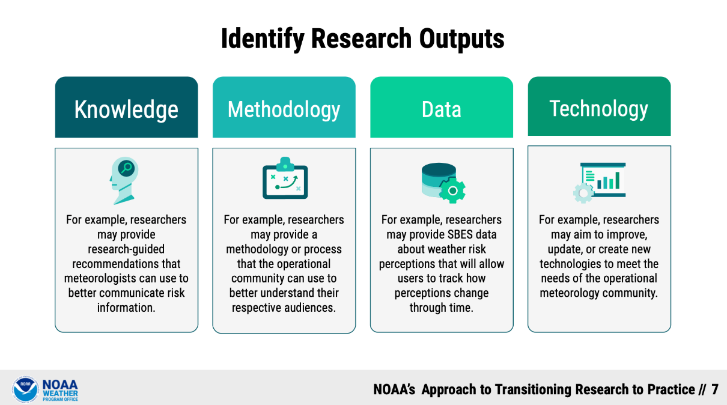

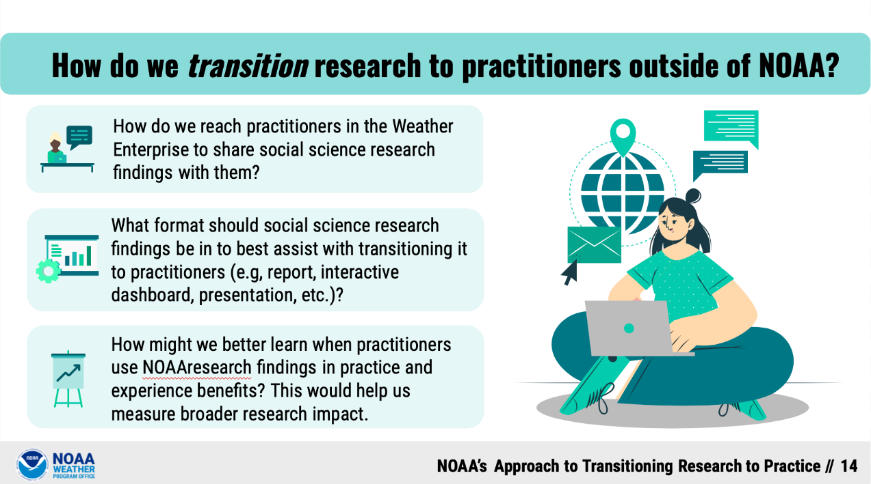
NOTES:

QUESTIONS TO CONSIDER
- How do we reach practitioners in the Weather Enterprise to share social science research findings with them?
- What format should social science research findings be in to best assist with transitioning it to practitioners (e.g, report, interactive dashboard, presentation, etc.)?
- How might we better learn when practitioners use our research findings in practice and experience benefits? This would help us measure broader research impact.

KEY CONCEPT: WARNING DECISION TRAINING DIVISION & TORFF MODULES

GENERAL INFORMATION
The Warning Decision Training Division (WDTD) develops and delivers training on the integrated elements of the warning process. In 2020, they were tasked with developing a training module to address TORFF issues with NWS forecasters. In part, content was based on a TORFF case study in a social science publication, interviews & collaboration with NWS WFOs, IDSS, and NOAA HQ, as well as conversations with Subject Matter Experts.
Publication: Henderson, J., Nielsen, E. R., Herman, G. R., & Schumacher, R. S. (2020). “A hazard multiple: Overlapping Tornado and flash flood warnings in a National Weather Service Forecast Office in the Southeastern United States.” Weather and Forecasting, 35(4), 1459-1481.
The original module includes challenges and best practices for NWS forecasters who are assessing and warning for overlapping tornado and flash flood warnings. It can be found here as part of the Warning Operations Course for severe weather: https://training.weather.gov/wdtd/courses/woc/severe/storm-structures-hazards/tornado/tor-flash-flood/story.html
KEY SLIDES
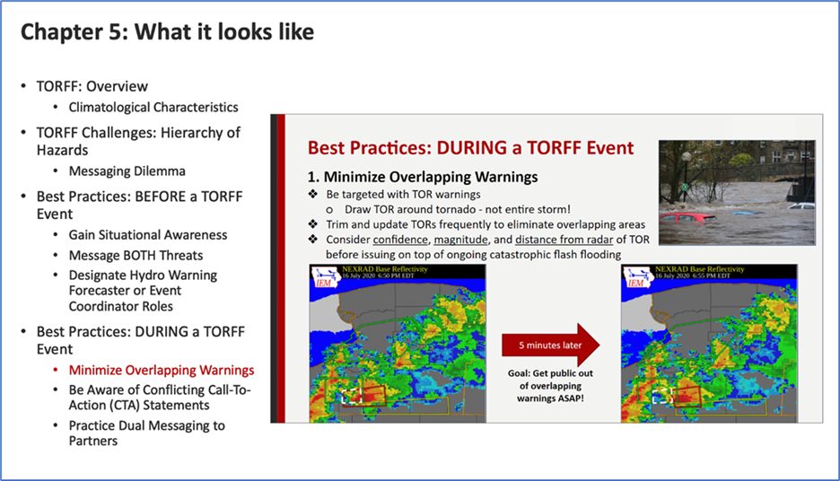

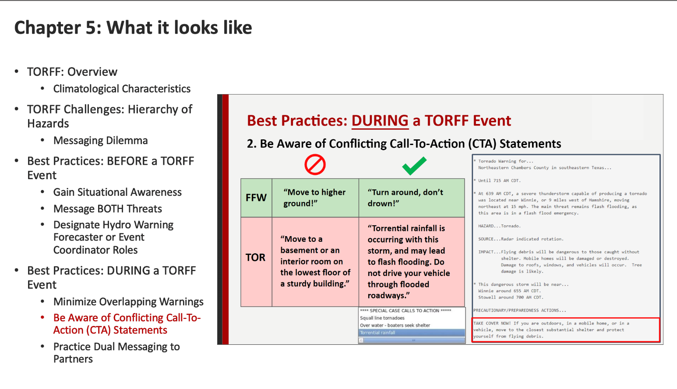
NOTES:

Not only is there a module but now there is a 2-day training exercise for NWS forecasters at the Hazardous Weather Testbed.
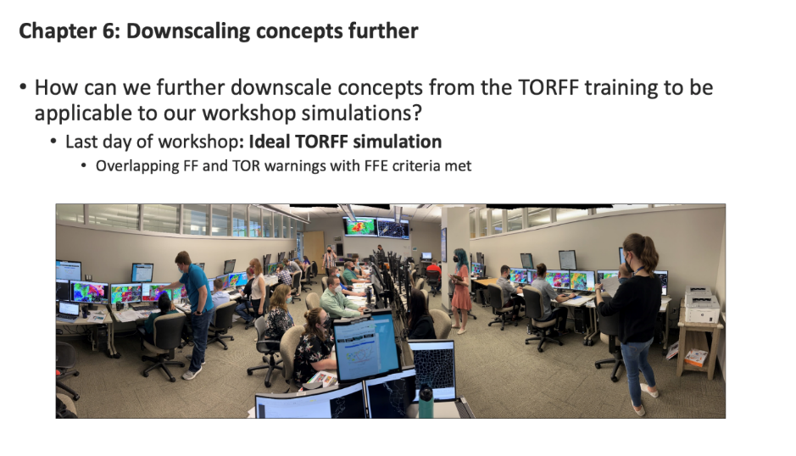

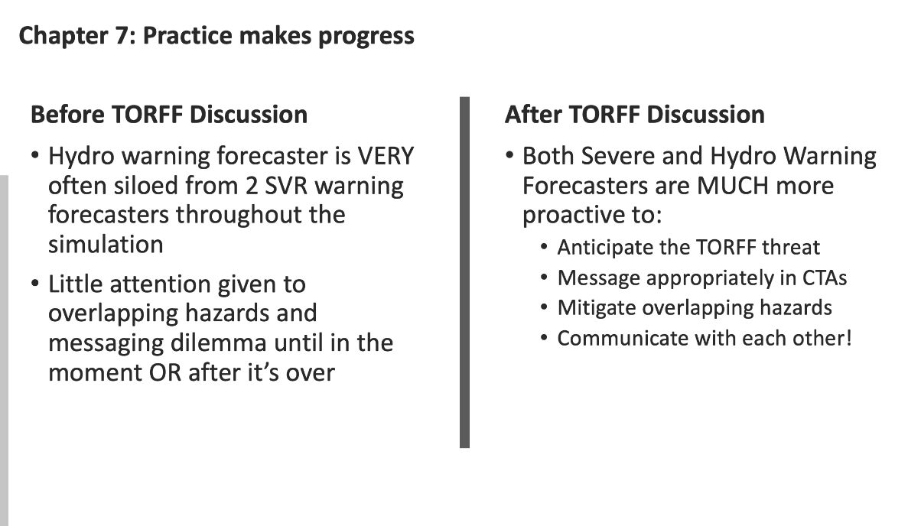
NOTES:

Next steps are to create a training module for TORFFS in Landfalling Tropical Cyclones.

QUESTIONS TO CONSIDER:
- What does coordination before and during TORFF events look like between NWS Meteorologists, Broadcast Meteorologists, and Emergency Managers?
- How are NWS warnings and graphics used and disseminated by Broadcast Meteorologists and Emergency Managers (e.g. Is attention to Calls to Actions in TORFF scenarios making a difference)?
- Are there ways that broadcast meteorologists and emergency managers might use or build on these training modules?

KEY CONCEPT: LTC TORFF DATABASE

TORFF BACKGROUND:
The TORFF climatology database was created by Erik Nielsen & Russ Schumacher to help identify the seasonality and location of overlapping tornado and flash flood warnings. Warnings are shown if they overlap in space and are valid within 30 minutes of one another, calculated as described in Nielsen et al. (2015, Weather and Forecasting). The images are updated once per day at approximately 1200 UTC.
Database: https://schumacher.atmos.colostate.edu/weather/TORFF_rt/
Publication: Nielsen, E. R., Herman, G. R., Tournay, R. C., Peters, J. M., & Schumacher, R. S. (2015). “Double impact: When both tornadoes and flash floods threaten the same place at the same time.” Weather and Forecasting, 30(6), 1673-1693.

We are attempting to create a useful database that can be helpful in assessing other overlapping products, like watches and outlooks or watches with warnings or NHC products with NWS products. See examples below:

KEY SLIDES: LTC TORFF POSSIBILITIES
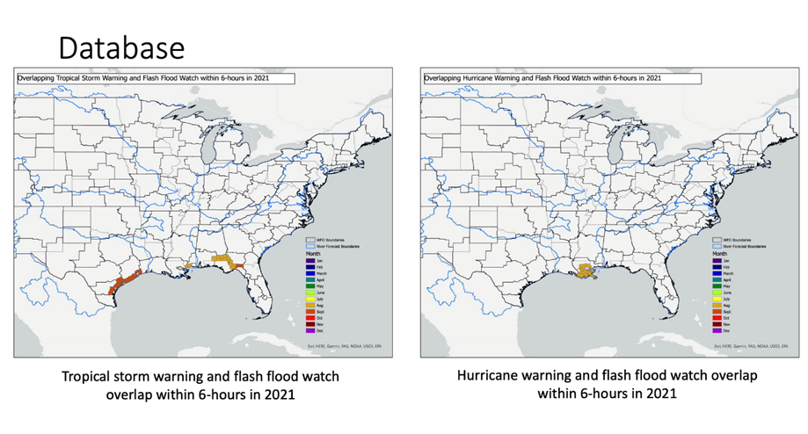
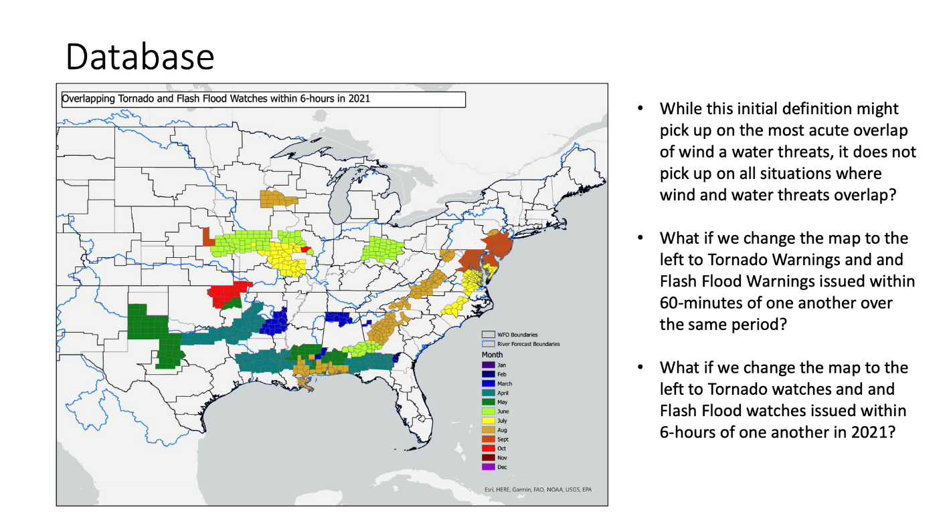

NOTES:

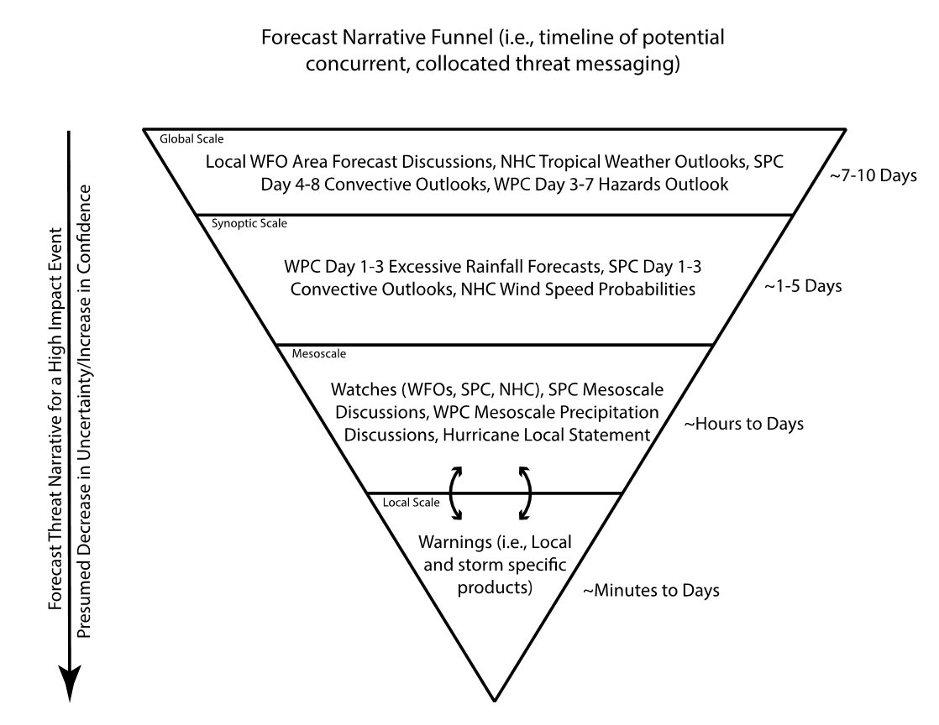

BREAKOUT ROOM QUESTIONS:
- What type of threat overlaps are the most useful or important for us to investigate for your office?
- In addition to watch / warning timescale, is there a critical timeframe in your threat messaging process where hazard prioritization takes place or changes?
- What format is most useful for applying this database to your own workspaces?

WRAP-UP and Key Insights: DAY 2

PEOPLE


WORKSHOP DIRECTION
JEN HENDERSON
Jen.Henderson@ttu.edu

RODOLFO HERNÁNDEZ-PÉREZ
Rodolfo.Hernandez@ttu.edu

WORKSHOP COORDINATION
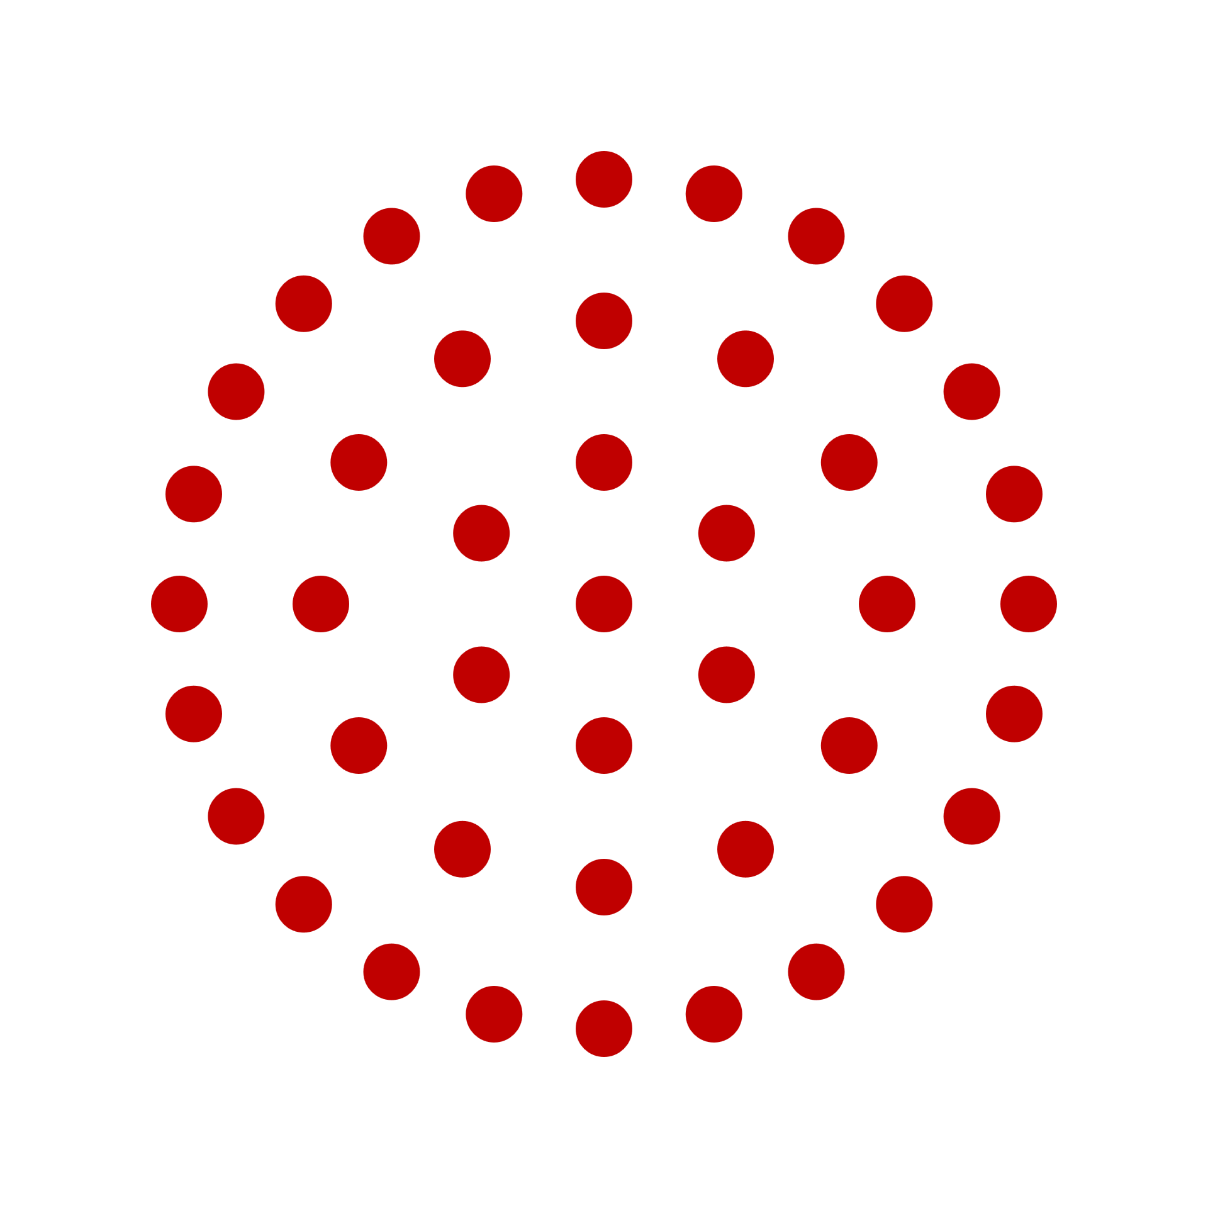
ERIK NIELSEN
ernielsen@tamu.edu
GINA EOSCO
Gina.Eosco@noaa.gov
CASTLE WILLIAMSBERG
castle.williamsberg@noaa.gov
CASSANDRA SHIVERS
cassandra.a.shivers@noaa.gov
KATARINA CHRISTIAN
katy.christian@noaa.gov

FACILITATORS
MEGAN PORTER
megan.s.porter@ttu.edu

BLAKE CHECKOWAY
blake.checkoway@ttu.edu

WEBSITE
KEELY PATELSKY
keely.patelski@ttu.edu

